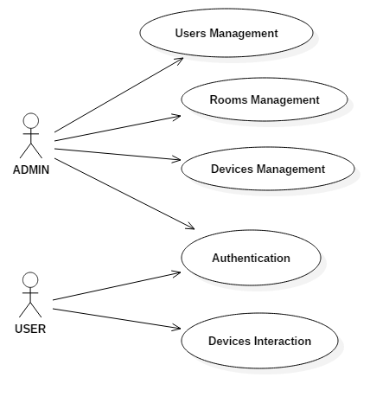Illustration 1: Use Case diagram for Home Automation application

Common Use Cases for all roles (any user)

Use Case “Authentication”
Main scenario:
- Any user tries to login. If he is not a registered user he signs-up instead.
- Any user can see his home page.

Alternative scenario:
1a. Any user fails to login or sign-up because of wrong credentials or information provided.
1b. The system asks again for credentials or sing-up information.
Use Cases for ADMIN role

Use Case “Users Management”
Main scenario:
- Admin is in their home page.
- Admin can select from menu to manage users.
- The system displays a list of all users registered with all their details presented.
- Admin can update details of a user.
- Admin can remove a user.
- Admin can add a new user.
- Admin can assign a device to a user or unassign a device from a user.

Use Case “Rooms Management”
Main scenario:
- Admin is in their home page.
- Admin can select from menu to manage rooms.
- The system displays a list of all rooms in the house with all their details presented.
- Admin can update details of a room.
- Admin can remove a room.
- Admin can add a new room.

Use Case “Devices Management”
Main scenario:
- Admin is in their home page.
- Admin can select from menu to manage devices.
- The system displays a list of all devices in the house with all their details presented.
- Admin can update details of a device.
- Admin can remove a device.
- Admin can add a new device.
- Admin can move a device to a different room.
- Admin can interact (change temperature, lighting illumination, etc) with any device.

Use Cases for USER role

Use Case “Devices Interaction”
Main scenario:
- User is in their home page and a list of all devices assigned to them is displayed by default. This list presents all the details of each device.
- User can interact with any device they are assigned to and is able to view. They can only change the status (on/off) and an indicator value accompanying the device. This value can be, for instance, temperature for an air-condition, lighting illumination for lights, etc.

